Active Site prediction server will predict the cavity points in a protein and dock the ligand molecule at the top ten cavity points predicted

- Upload the target protein in PDB format.
- Specify your email Id in the text box, as the program might take few minutes to process the query.
Result
The result page will display the various cavity points in the target protein.
For eg:
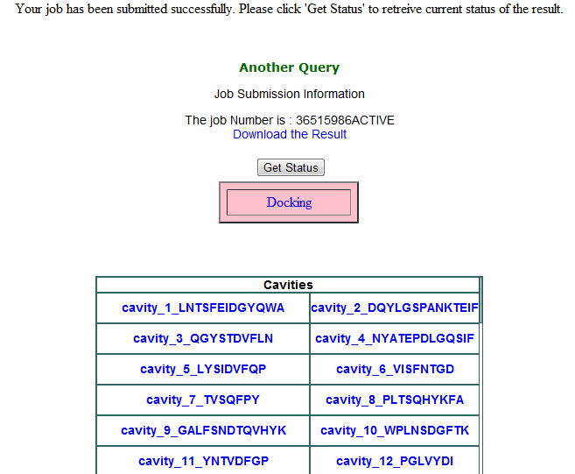

The result is displayed in the following format. The different cavity sites along with one letter code of amino acid residues surrounding the respective cavity is displayed. Click on the respective cavity links in blue to analyze the xyz coordinates on the cavity along with an approximate volume of the cavity in cubic Angstrom. For the abo
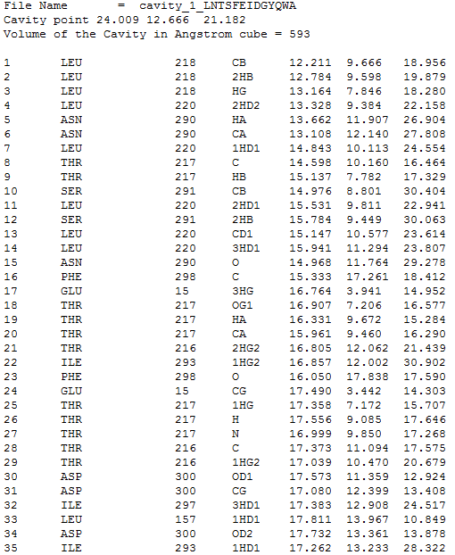

The above kind of page gets displayed. It represents the xyz coordinate of the first cavity as 12.211 9.666 18.956 and a volume of 593 in Angstrom cube. It also depicts the various amino acid residues lining the cavity. The first column specifies the atom number. Second the amino acid residues surrounding that cavity. Third column specifies the amino acid number. The fourth column is the atom name. The fifth, sixth and seventh column is the x y z coordinates of the atoms in the third column.
To visualize different cavity points kindly click on the <Download the Result> button
The file can be graphically viewed by using certain softwares like Viewerlite, Mercury, Swissmol PDBviewer (spdv).

Docking
The program will automatically dock the candidate drug molecule at the top ten cavity points predicted by the active site finder. Click on docking button which will take you to the docking page
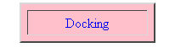
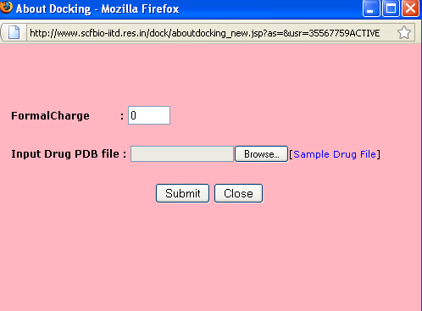

Specify the formal charge of the molecule you want to dock. Kindly input hydrogen added drug file and then click on the submit button.
Ten docked structures along with the binding free energies in kcal/mol will be emailed back to the user.
For any suggestion/comments/problem pl. contact tanya@scfbio-iitd.res.in

